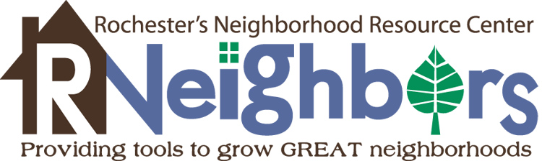
Board of Directors
Application

1421 3rd Avenue SE • Suite 225
Rochester, MN 55904
507.529.4150 • www.RNeighbors.org

Name: ______________________________________________________________________

Address: ___________________________________________________ Zip ______________

(E-mail)_______________________________________________ Years in Rochester: ______

Phone: (home) _______________________________ (cell) ___________________________

Occupation: _________________________ Employer: ______________________________

Why do you wish to serve as an RNeighbors board member?

How would your skills or experiences benefit RNeighbors and they strive to provide tools to GROW great neighborhoods?

Please tell us about yourself, such as education, achievements, special interests, passions, community participation, neighborhood involvement, etc. (attach resume, if desired).

Signature: __________________________________________ Date: ___________________

We thank you for your interest in strengthening Rochester neighborhoods. Please return to: RNeighbors via email to rene@RNeighbors.org or by snail mail to 1421 3rd Avenue SE, Rochester, MN 55904.

